PRE-PRIMARY ORIENTATION PROGRAMME FOR PARENTS

‘A new academic year brings new challenges and opportunities to learn and grow.’

On 12th July 2025, an Orientation Programme was conducted to engage parents in shaping their children’s future success.

‘Education is not the learning of facts, but the training of mind to think.’ Parents and teachers collaborate to support a child’s learning journey, which help them to grow from a tiny tot to a confident student.


Our educators gave a warm welcome to parents.
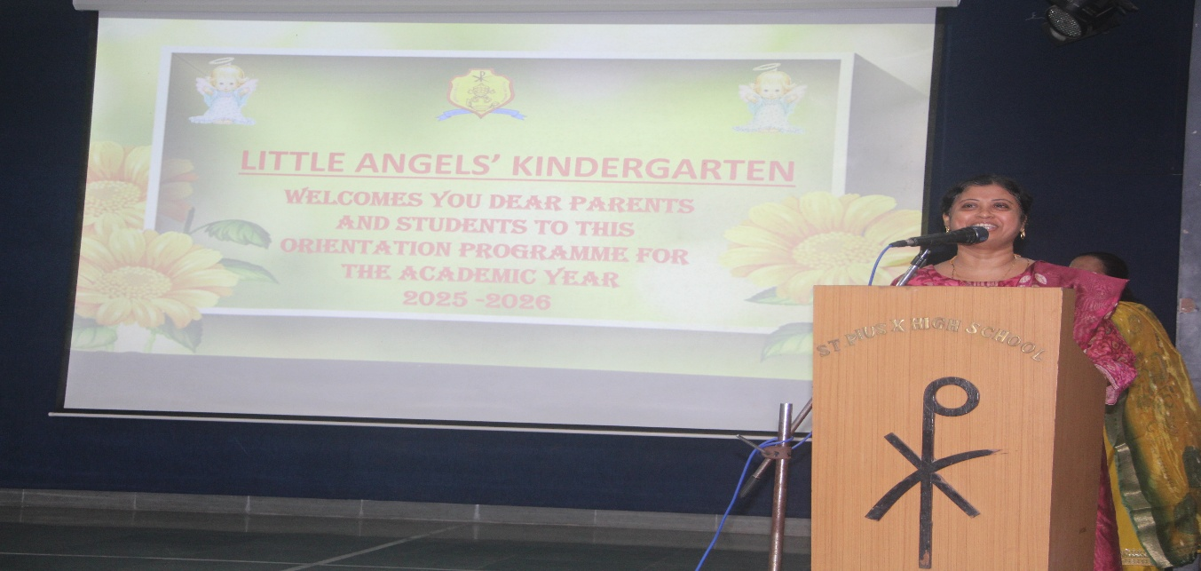
It was followed by an insightful introduction to our institution’s vision, mission and values.
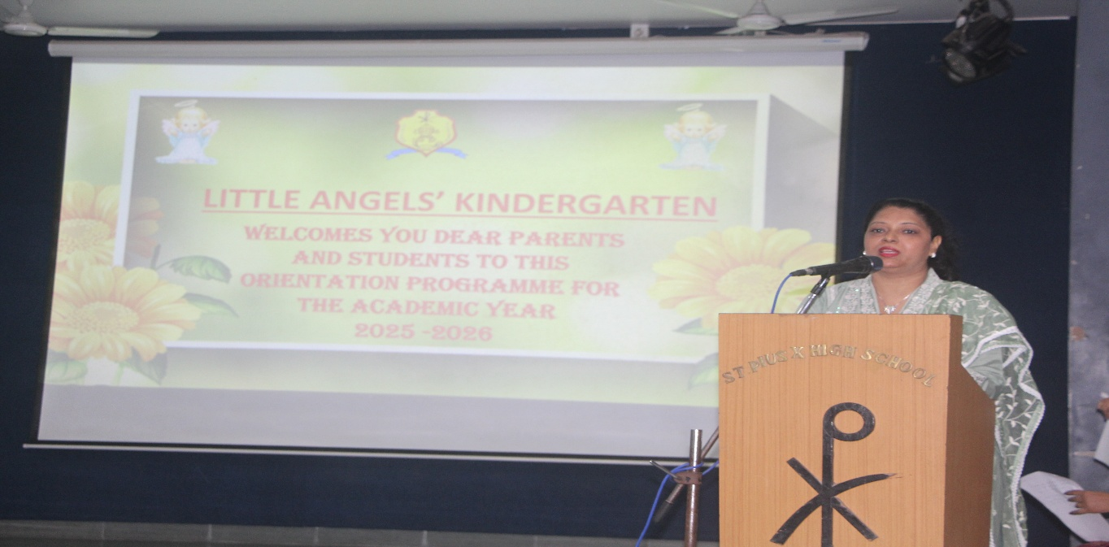
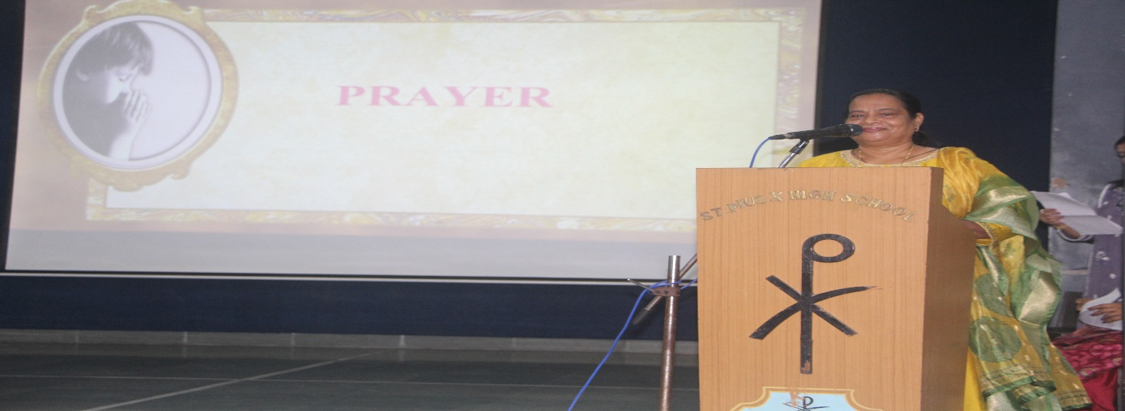
The programme commenced with a Prayer

A Power point presentation was showcased to highlight the Academic Report for the year 2024-2025 which featured the overall development of a student- academically, socially and personally throughout the year.
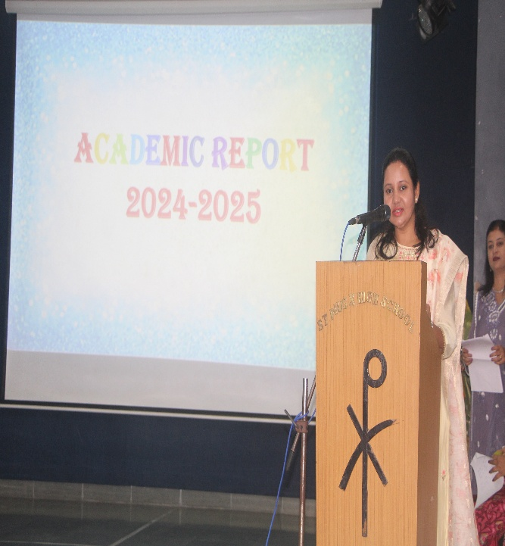
Co-curricular Report gave an overview of a student’s involvement and performance in activities beyond academics. These activities help in the holistic development of the child where the students take actively take part in dance, sports and competitions like Fancy-dress, Poetry, Storytelling, Patriotic singing etc.
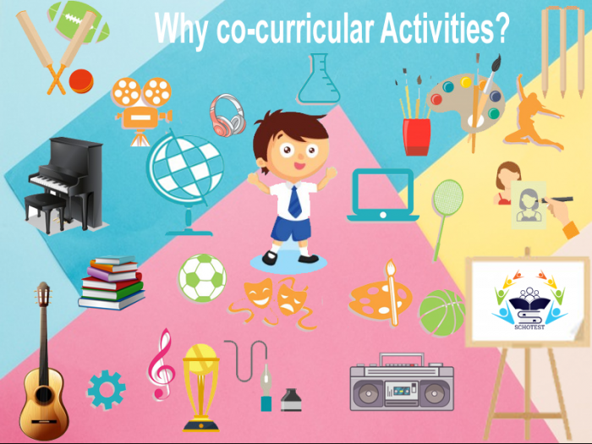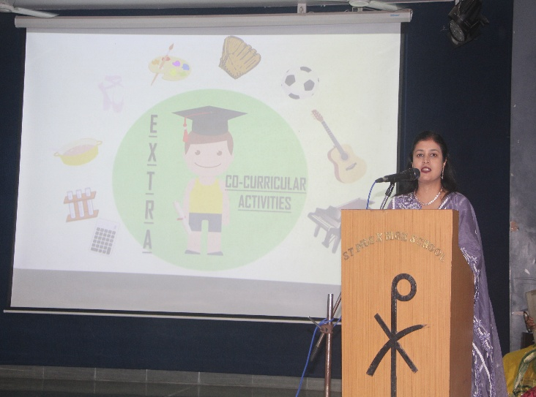
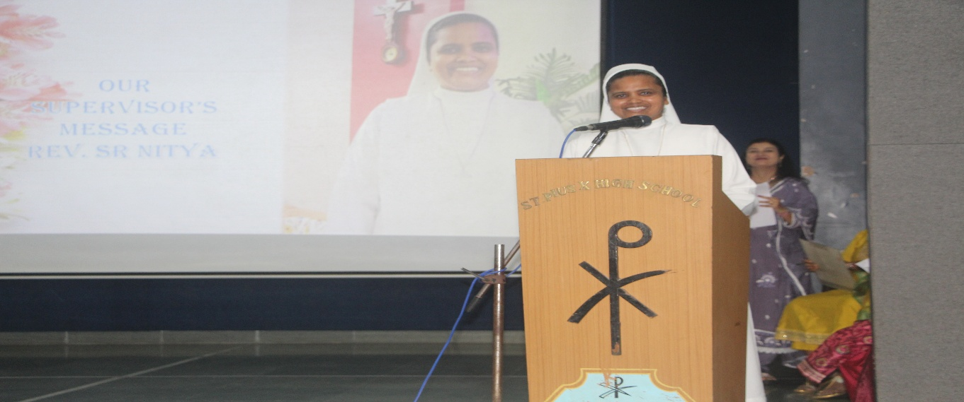
Our supervisor Respected Sr. Nitya extended a warm welcome to parents and emphasized the importance of student hygiene and healthy eating habits and responsibility of parents regularly check the diary for updates.
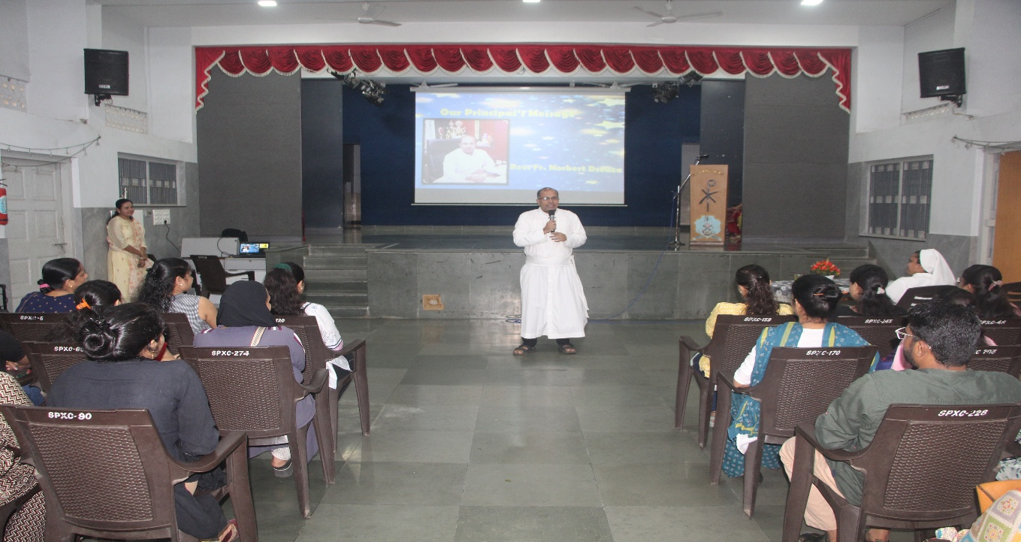
Our dear Principal Rev. Fr. Norbert Dsouza addressed the gathering highlighting key areas such as the school’s functioning, online fee payment system, the value of punctuality and discipline, the academic and personal growth of the students.

event wrapped up smoothly, setting a positive tone for the new academic session.
